SUMMER ART TRAIL

SPONSORSHIP FORM
SPONSORSHIP APPLICATION PACK

PERSONAL INFORMATION

Full name: CRN:

Business name:

Business address:

Contact number:

Contact email:

Website:

Please attach with this application a high quality logo of your business to be used on our website and in advertising material.

SPONSORED PROJECT

Please specify what project you would like to support for Summer Art Trail.
Please highlight the text that applies. If you would like to select more than one your contribution will be distributed across the relevant projects.

Summer Art Trail Artist Residency

Summer Art Trail Open Call

Summer Art Trail Internship and Volunteer Programme

Summer Art Trail (events)

Magic Teapot Launch Event

Myoptik’s Closing Sound Ceremony

SPONSOR FEE

Amount:

PLEASE CONTINUE TO NEXT PAGE

WANT ADDITIONAL ADVERTISING? (optional)

For further business outreach you may wish to purchase additional advertising space in our (A5) Summer Art Trail festival booklet, distributed across the city.
Please highlight the text that applies.

£220 Full page
£120 Half page
£50 Quarter page

EVENT APPLICATION FORM (optional)

TERMS AND CONDITIONS

Summer Art Trail celebrates diversity and inclusiveness within the arts. While the festival is 10 days your event can for your own specified amount of time.

Summer Art Trail is planned and coordinated by Silver Vine Arts; a non-profit, community interest, artist led organisation.

Are values are:
- Supporting artists and creative organisations
- Bringing the community together through creative events
- Enhancing inclusivity in the arts

Your business should:
- Share some or all of the same values as Silver Vine Arts
- Be of high quality delivery
- Have a passion for visual and/or performance arts

Summer Art Trail will:
- Provide support and advertise your business through our following outlets – website, festival booklet, trail map
- Keep you updated regularly with recent developments leading up to and during Summer Art Trail 2016
- Provide promotional material for the festival

Important dates:

20th May Deadline to submit application form
June (tbc) Meeting with all businesses involved discussing details
1st July Deadline for updated information of events
20th July Summer Art Trail booklet launch
20th – 29th Aug Summer Art Trail 2016

FEES

Please highlight the text that applies

£52 Big business
£20 Small business
£15 Individual

PAYMENT

Please make the correct payment using back transfer.
Note – bank transfer details pending and will be provided once available.

In order for Silver Vine Arts to maintain a record of your transaction please reference your business and the reason for making the payment.

EVENT DETAILS

What is your event at Summer Art Trail?
Please highlight the text that applies

Exhibition Stall Workshop
Performance Comedy Music
Pop up Other
(please specify)

Please write in a few sentences a brief description of your event AND attach a small selection of high quality images to promote your event (you must own the rights to images you attach). This information will be used on our website and in advertisements for the trail:

Dates and times of event:

Event address:

Is your event address wheelchair
accessible? Yes / No

Do you have liability insurance? Yes / No

If your event will potentially be working with vulnerable adults and/or children you must have a valid DBS for staff coordinating it.

At Silver Vine Arts we are always looking to utilise unused spaces for artists.
Do you have a space available that you would like to offer in kind for a group artist residency, Silver Vine Arts meet space and/or Artist Open Call exhibition space?

Please highlight the text that applies
Group Artist Residency (May – August)
Artist Open Call exhibition (August)
Silver Vine Arts meet space (May – August)

Please describe the space and specifications (if available):

PLEASE CONTINUE TO NEXT PAGE

DISCLAIMER

Summer Art Trail is an arts festival that celebrates inclusivity and community involvement; therefore your scheduled event must be free to the public or a substantially small fee.

Stickers and banners provided by Summer Art Trail must be clearly displayed at all times during the time of your event. We as an organisation own the right to the design of Summer Art Trail graphics and the ideas behind each project. If you have any concerns about how your business is being represented please discuss with us to rectify. We welcome discussion and feedback to positively develop our organisation.

Any online promotion of the event must provide a link directed to Summer Art Trail’s website. Please note that Summer Art Trail’s website is currently undergoing a redesign and the new URL will be provided to you once live.

All businesses involved must encourage visitors to go to other venues on the trail and might be required to record visitor numbers and take photographs of the event.

All businesses must make themselves available for a meeting in the lead up to the trail to go over all of the final details. The date of the meeting will be provided with plenty of notice closer to the date of the festival.

By providing your name and date below you are agreeing to Summer Art Trail’s terms and conditions and disclaimer. You are also agreeing that all information you have provided is correct to the best of your knowledge.

Full name: Date:

Once complete please send this application as a PDF.doc to summerarttrail.info@gmail.com along with payment and supporting documents and/or images.
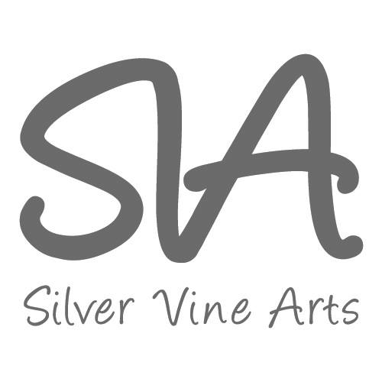
www.silvervinearts.wix.com/summerarttrail
silvervinearts@gmail.com

